
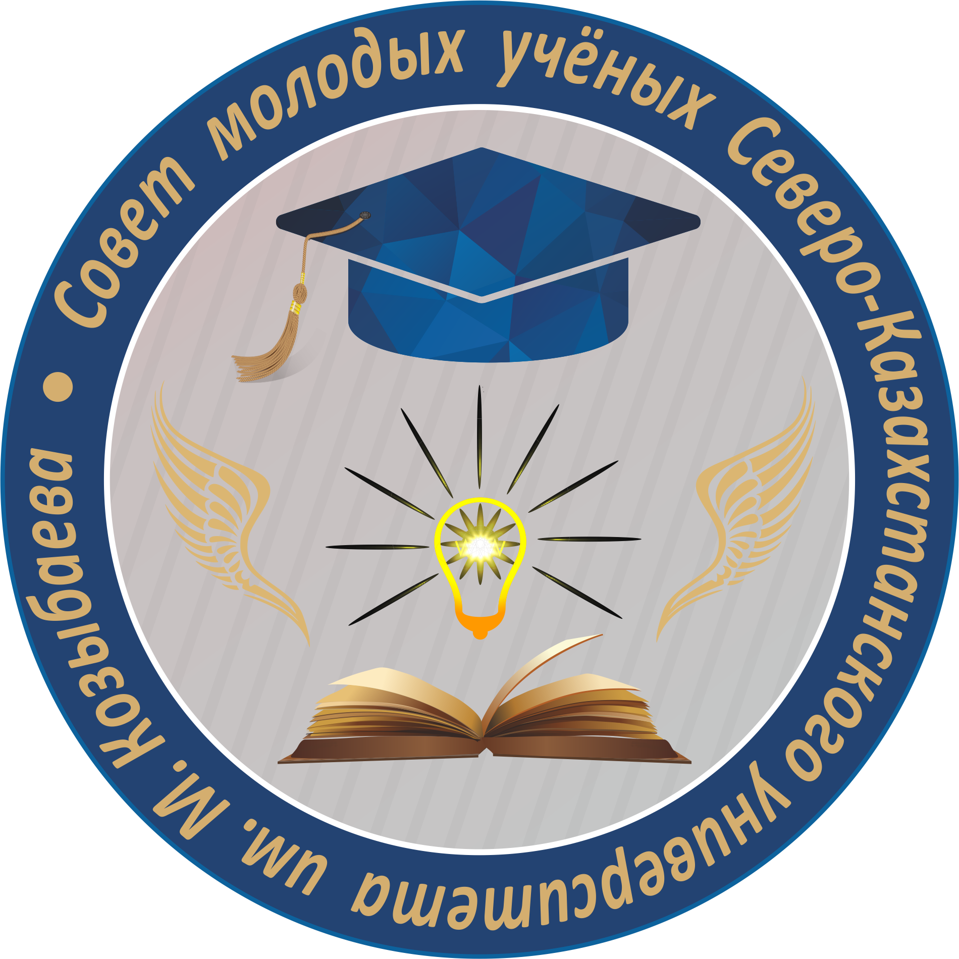
MINISTRY OF EDUCATION AND SCIENCE
OF THE REPUBLIC OF KAZAKHSTAN
NORTH KAZAKHSTAN UNIVERSITY
NAMED AFTER M. KOZYBAYEV

INFORMATION LETTER
Dear Students and Faculty!
Council of Young Scientists of the NKU named after M. Kozybayev is holding a competition of scientific Start-up projects.
The purpose of the competition: to support young researchers of NPLC “NKU named after M. Kozybayev" through the implementation of innovative projects, which are based on the result of research activities.
Participants of the competition: due to the fact that the winners of the competition bear obligations in the post-competition period, students of 1-3 courses of bachelor's and master's students of the 1st year (non-graduation courses) are allowed to participate in the competition.
Competition plan: The competition will be held in two stages: in absentia format (semi-final stage) on April 20-22, 2022 and offline (final stage) on April 25, 2022.
Competition procedure: participants of the competition send applications (according to the Appendix) with a brief description of their scientific projects to the e-mail of the competition commission smu@ku.edu.kz until April 20, 2022. The electronic application must contain: full name of the participant, faculty, group, contact numbers, e-mail, project name, brief annotation, practical significance, scope, novelty, etc. Photo or video materials demonstrating the project (if any) can be attached to the letter.
At the preliminary stage, the best works are selected for participation in the final stage. The final will be held on April 25, 2022 (room 115 of LC №1) in the format of a debate, where participants will present their projects (presentation no more than 15 slides, 10-15 minutes for a speech).
Criteria for evaluating a scientific project:
- scientific novelty;
- technological features and uniqueness of the project;
- practical significance of the project;
- payback;
- profitability;
- expected economic and social effect from implementation;
- reliability of economic and technical calculations.
The results of the competition will be summed up no later than April 29, 2022. According to the results of the competition, the three winners will be allocated funds in the amount of 80,000 (eighty thousand tenge) to promote their scientific project with the prospect of commercialization.
Post-competition period: within a calendar year from the date of the end of the competition, the winners must: 1. Obtain a certificate of implementation of their scientific project at enterprises working in this area or apply for an author's certificate 2. Publish 1 (one) article in a publication recommended by CQAES or in an equivalent to it a foreign edition indexed in the Russian Science Citation Index.
For all additional questions, please contact Petrov Pavel Anatolyevich, Chairman of the Council of Young Scientists (87055698255).
Council of Young Scientists
NKU named after M. Kozybayev

Appendix 1

Application for a participant in the competition of scientific Start-up projects

Based on this application, a primary (semi-final) selection of projects will be made. Try to briefly but informatively describe your work.

FULL NAME of participant
Faculty, group
Phone
E-mail
The name of the project
Brief abstract to the scientific Project (no more than 200 words)
Practical significance of the Project

Sphere of implementation (potential enterprises for the implementation of the Project)
The uniqueness of the Project and its scientific novelty
Necessary financial resources for the implementation of the Project (cost estimate)
Project implementation stage (primary, in development, at the final stage, fully completed)

Project participant's signature

